*The Preparation of a Culinary Colloid – Mayonnaise*

From *On Food and Cooking* by Harold McGee

Mayonnaise is an emulsion of oil droplets suspended in a base composed of egg yolk, lemon juice or vinegar, water, and often mustard, which provides both flavor and stabilizing particles and carbohydrates. It’s the sauce most tightly packed with oil droplets-as much as 80% of its volume is oil--and is usually dense and too stiff to pour. It can be thinned and flavored with various water-based liquids, including purees and stocks, or it can enrich such liquids the way cream does; it can also be aerated with the addition of whipped cream or egg whites. As a room-temperature preparation, mayonnaise is generally served with cold dishes of various sorts. But thanks to the yolk proteins, it also reacts usefully to heat. It lends body and-richness when added to thin broths and briefly cooked; and when layered onto fish or vegetables and broiled, it moderates the heat, puffs up and sets into a rich coating.

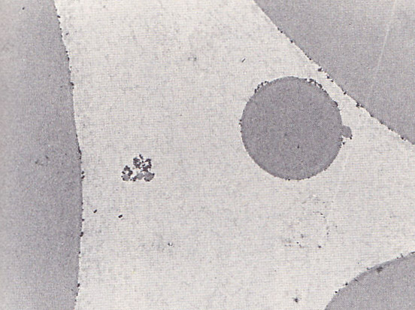 Traditionally, mayonnaise is made with raw egg yolks and therefore carries a slight risk of salmonella infection. Manufacturers use pasteurized yolks, and cooks concerned about salmonella can now find pasteurized eggs in supermarkets. Both vinegar and extra-virgin olive oil kill bacteria, but mayonnaise is best treated as a highly perishable food that should be served immediately or kept refrigerated

**Making Mayonnaise.** All of the ingredients for making mayonnaise should be at room temperature; warmth speeds the transfer of emulsifiers from the yolk particles to the oil droplet surfaces. The simplest method is to mix together everything but the oil - egg yolks, lemon juice or vinegar, salt, mustard, and then whisk in the oil, slowly at first and more rapidly as the emulsion thickens. However, the cook can produce more stable small, droplets by whisking a portion of the oil into just the yolks and salt to start, and then adding the remaining ingredients when the emulsion gets stiff and needs to be thinned. The salt causes the yolk granules to fall apart into its component particles, which makes the yolks become both more clear and viscous. If left undiluted, this viscosity will help break the oil into smaller droplets.

***Figure 1****. Oil droplets in mayonnaise. A view through an electron microscope. Protein and emulsifier molecules and aggregates, all from egg yolk, are present between the large droplets and on their surfaces, and help prevent them from coalescing.*

Though cookbooks often say that the ratio of oil to egg yolk is critical, that one yolk can only emulsify a half-cup of oil, this just isn't true. A single yolk can emulsify a dozen cups of oil or more. What is critical is the ratio of oil to water: there must be enough of the continuous phase for the growing population of oil droplets to fit into. For every volume of oil added, the cook should provide about a third of that volume in the combination of yolks, lemon juice, vinegar, water, or some other water-based liquid.

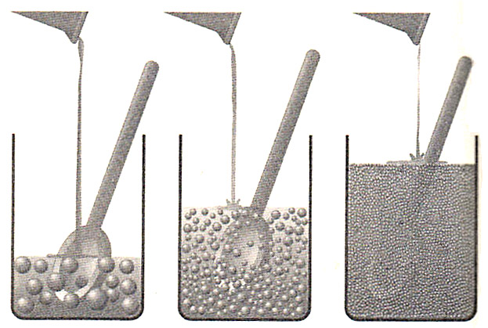

***Figure 2****. Making mayonnaise. The cook begins with a small volume of the water phase – mostly egg yolk - and slowly beats oil into droplets in this base (left). As more oil is incorporated, the mixture becomes thicker and the oil is broken into smaller droplets (center). When the sauce is done, as much as 80% of its volume is occupied by oil droplets, and its consistency is semisolid (right).*

**A Sensitive Sauce**. Because mayonnaise is chock-full of oil, so much so that the droplets press up against each other, its emulsion is easily damaged by extremes of cold, heat, and agitation. It will tend to leak oil in near-freezing refrigerators and on hot rather than warm food. These problems are ameliorated in manufactured mayonnaise by the addition of stabilizers, usually long carbohydrate or protein molecules that fill the spaces between droplets.



**Ingredients**   
  
1 egg yolk*   
1/2 teaspoon fine salt   
1/2 teaspoon dry mustard   
2 pinches sugar   
2 teaspoons fresh squeezed lemon juice   
1 tablespoon white wine vinegar   
1 cup oil, safflower or corn  
  
**Directions**   
  
In a glass bowl, whisk together egg yolk and dry ingredients. Combine lemon juice and vinegar in a separate bowl then thoroughly whisk half into the yolk mixture. Start whisking briskly, then start adding the oil a few drops at a time until the liquid seems to thicken and lighten a bit, (which means you've got an emulsion on your hands). Once you reach that point you can relax your arm a little (but just a little) and increase the oil flow to a constant (albeit thin) stream. Once half of the oil is in add the rest of the lemon juice mixture.   
  
Continue whisking until all of the oil is incorporated. Leave at room temperature for 1 to 2 hours then refrigerate for up to 1 week.

Recipe from Alton Brown